Linear Algebra

Laboratory Activity No. 10

**Linear Transformations**

|  |  |
| --- | --- |
| *Submitted by:* | *Instructor:* |
| Guy, Lawrence Adrian B. | Engr. Dylan Josh D. Lopez |

January, 01, 2021

# Objectives

The laboratory activity aims to familiarize students with other linear transformations through the use of matrix operations. The activity shows visualizations of different linear transformations using Matplotlib.

# Methods

The practices of the activity are to use matrix operations to transform matrices. The linear transformations included in the activity are shearing, scaling, and rotations. For each linear transformation, a visualization is presented to further understand each linear transformation

The deliverable of the activity is to perform the linear transformation in a span using the scatterplot view. The deliverable is achieved by using NumPy for computations and Matplotlib to visualize the transformed matrix.

# Results

The results of this laboratory activity before and after performing a linear transformation on the matrix created are seen below.

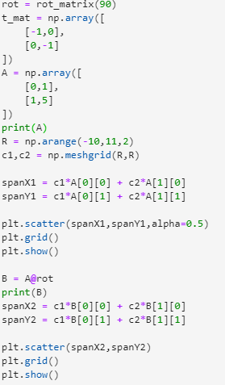

Figure 1 Codes used for lab 10

Seen in figure 1 are the codes used for linear transformation on matrix A. The linear transformation used is the rotation of the matrix. The programmer utilized the created function of the professor to achieve the rotation of the matrix. The matrices are visualized using Matplotlib.

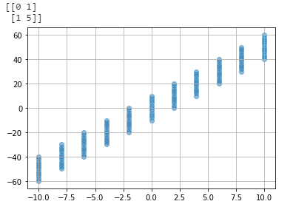

Figure 2 Output for the base span of matrix A

Figure 2 shows the visualization of the span of matrix A. The view used for the visualization is a scatterplot view.

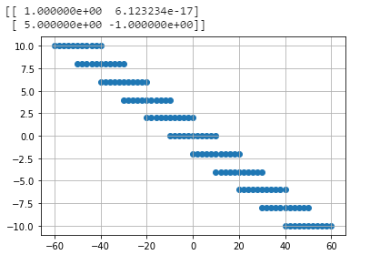

Figure 3 Output for the transformed matrix A

Figure 3 shows the output when matrix A is transformed using rotation. The variable name given for this matrix is B. As seen in the output, after rotating the matrix to 90 degrees, it changed its position from a vertical span into a horizontal span.

# Conclusion

The laboratory activity showed different linear transformations and their effects on the original matrix. The activity utilized Python with NumPy and Matplotlib to perform and visualize these linear transformations.

Linear transformations are important as they preserve the structure of the vector space [1]. Linear transformations are useful not only to people in Computer Science/Engineering field. One of the applications of a linear transformation is in animation and computer graphics. An understanding of linear transformation is key to mastering these two[2].

There are many more practical applications of linear transformations in other fields. One of them is in mechanics. Specifically one of the branches of mechanics, kinematics. In kinematics, angles can be computed using linear transformations. Some of the linear transformations used are rotation and translation. These rotations of angles can be applied in robotics to rotate the robot’s arm. [3]

**References**

[1] Brilliant.org, “Linear Transformations.” https://brilliant.org/wiki/linear-transformations/ (accessed Jan. 01, 2021).

[2] V. China Venkaiah and V. Sesha Phani Deepika, “Computational Analysis and Understanding of Natural Languages: Principles, Methods and Applications,” in *Handbook of Statistics*, 1st ed., G. Venkat and R. C.R., Eds. North Holland, 2018, pp. 2–215.

[3] Walter, “How are angles computed?” https://walter.readthedocs.io/en/latest/Kinematics/ (accessed Jan. 01, 2021).

**Appendix**

Github Repository Link:

https://github.com/Loreynszxc/Linear-Algebra-Lab-10